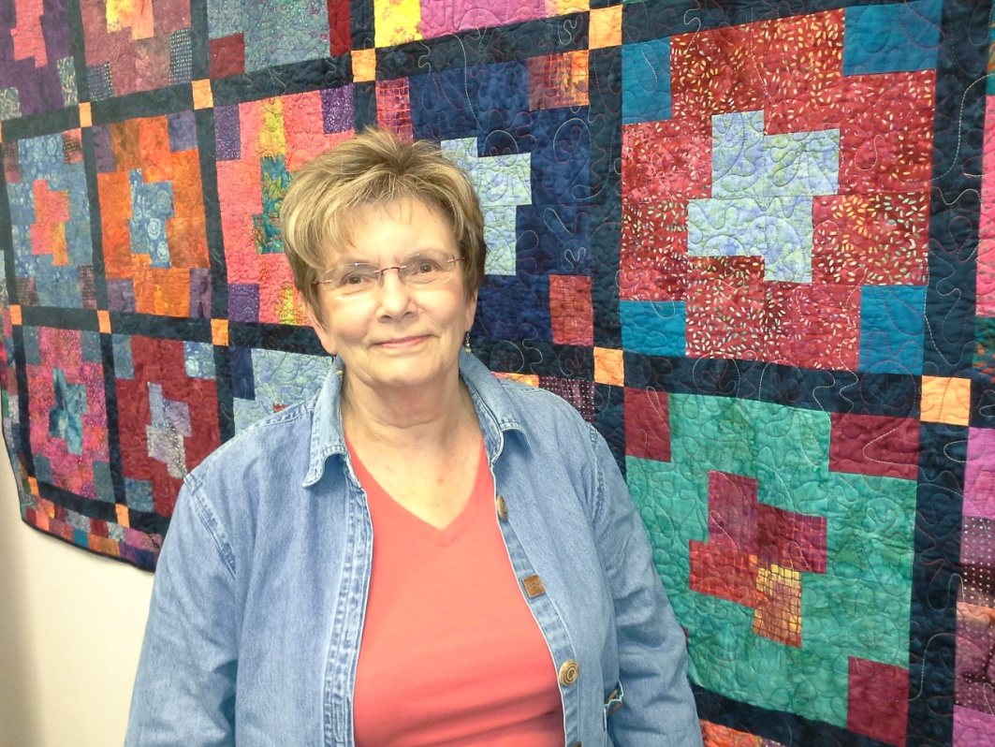
Jeanne Evert
Featured Mazomanie Quilter

Mazomanie Free Library
102 Brodhead Street, Mazomanie, WI 53560
Hours: M-Thurs, 10-12; 2-7; Fri, 10-5, Sat 10-1
608 795.2104
Show runs through July

It is a privilege to have some of my quilts hanging in the Mazomanie Free Library during the 115th library anniversary.

My name is Jeanne Evert and I have lived in the Mazomanie area most of my life. For the last 30 or so years my husband, Carl and I have lived on his family farm on Highway 19, near Marxville. My maternal great-great-grandmother and father (John and Jane Lees) emigrated from England in 1845. About 50 years before the Mazomanie Free Library was founded. I attended the Mazomanie Grade School and High School. I was the oldest daughter of Eloise and Donald Wieneke and the first granddaughter of William and Jessie Lees Mahony and niece to Jeanne Mahony and Frances Dye. My parents, myself, sister and brother lived across the street from the Dye and Mahony’s. Lots of wonderful memories growing up in the village with family so close.

I learned to sew my freshman year in High School, but did not start quilting until 1990. My mother quilted so -- how could I want to do that! A favorite pastime of mine is visiting the many quilt shops we have in our area. My friends know that I am ready and willing to go on a quilting road trip most anytime. I now have an extensive collection of fabrics that I am able to draw from. Carl keeps asking if I really need that entire inventory. I remind him of all the tools and tractors he has.

As you can tell from my quilts I like to piece and machine quilt. I have someone quilt some of my larger quilts with a long-arm quilt machine. I hope that you will enjoy viewing my quilts during your visit to the library.

